B. V. V. Sangha’s


BASAVESHWAR ENGINEERING COLLEGE BAGALKOTE - 587102
2024-25
DEPARTMENT OF ELECTRONICS AND COMMUINCATION ENGINEERING MINI PROJECT [22UEC511P] REPORT ON

“IOT Based Indoor Air Quality Monitoring System”
Coordinators Project Guide HoD Dr. Mamata J. Sataraddi Prof. Supriya B.H Dr. Jayashree D.Mallapur Dr. Basavaraj M. Angadi

Project Submitted by :Sandeep. Sahebagoud. Patil

B. V. V. Sangha’s

BASAVESHWAR ENGINEERING COLLEGE BAGALKOTE - 587102
2024-2025
DEPARTMENT OF ELECTRONICS AND COMMUNICATION ENGINEERING

CERTIFICATE
This is to certify that the mini project report entitled “IOT Based Indoor Air Quality Monitoring System” submitted by Sandeep S Patil(2BA22EC084) studying in V semester during the year 2024-25 from Basaveshwar Engineering College, Bagalkote, in partial fulfilment for the award of degree Bachelor of Engineering in Electronics and Communication Engineering is a bonafide record work done by them under my supervision.
GUIDE | HoD PRINCIPAL
Prof. Supriya B.H | Dr. Jayashree D. Mallapur Dr. B. R. Hiremath
Examiner | Name of Examiner Signature
HOD/Nominee

Internal Examiner

External Examiner

DECLARATION
We hereby declare that this project report titled " IOT Based Indoor Air Quality Monitoring System" submitted in partial fulfillment of the requirements for the award of the degree of Bachelor of Engineering in Electronics and Communication Engineering, is a record of original work carried out by us under the supervision of Prof. Supriya B.H .This work has not formed the basis for the award of any other degree or diploma in this or any other institution or university. In accordance with ethical practices in reporting scientific information, due acknowledgments have been made wherever the findings of others have been cited.

ACKNOWLEDGEMENT
The satisfaction that accompanies the successful completion of this project would be incomplete without the mention of the people who made it possible, without whose constant endurance and encouragement would have made efforts go in vain. We considered privileged to mess gratitude and respect towards all those who guided us through the completion of this project.
We convey thanks to our project guide Prof. Supriya B.H . Department of Electronics and Communication Engineering, for their support and advice to get and complete the project on “IOT Based Indoor Air Quality Monitoring System”.
We would like to thank project Co-ordinators Dr. B. M. Angadi and Dr. M.J.Sataraddi Department of Electronics and Communication Engineering, for providing encouragement, constant support and guidance which was of a great help to complete the project successfully.
We are grateful to Dr. Jayashree D. Mallapur, Professor and Head of Department of Electronics and Communication Engineering, for giving us the support and encouragement that was necessary for completion of this project.
We would also like to express our gratitude to Dr. B. R. Hiremath Principal, Basaveshwar Engineering College for providing us congenial environment to work in.
We grateful to faculty and staff members of Department of Electronics and Communication Engineering, for providing the facilities which have helped in making this project a success.
Finally, we would like to thank our parents, friends and who helped to complete this project directly and indirectly, for their constant encouragement with moral and material support.

ABSTRACT

An indoor air quality monitoring system is designed to measure and track the quality of air inside buildings. It utilizes sensors to detect pollutants such as carbon dioxide, dust, humidity, and temperature. The system provides real-time data, enabling the maintenance of a healthy and comfortable indoor environment. By identifying harmful pollutants, it plays a vital role in improving air quality, ensuring better health, and enhancing safety for the occupants.

Sl No | Title | Page. No
1. | Introduction | 1
2. | Problem statement and Motivation | 2
3. | Objectives | 3
4. | Literature Survey | 4
5. | Block Diagram | 5
6. | Circuit Diagram | 6
7. | Methodology | 7
8. | Working Process | 9
9. | Outcomes | 10
10. | Conclusion | 11

1. Introduction
The Internet of Things (IoT) has revolutionized the way we approach indoor air quality (IAQ) monitoring by enabling interconnected devices to communicate and operate intelligently. Among its numerous applications, IoT-based IAQ monitoring systems have emerged as vital tools for enhancing occupant health and well-being in residential, commercial, and industrial environments. These systems leverage advanced sensors, communication technologies, and real-time data processing to monitor and control various IAQ parameters, such as temperature, humidity, carbon dioxide levels, and particulate matter, thereby creating healthier and more productive indoor environments.
Traditional IAQ monitoring methods often involve manual sampling and periodic measurements, which can be time-consuming, labor-intensive, and may not provide real-time insights. IoT-based solutions address these limitations by integrating smart sensors that continuously monitor a wide range of IAQ parameters and transmit real-time data to a central monitoring system or cloud platform.
IoT-based IAQ monitoring systems offer several advantages over conventional methods. First, their real-time monitoring capabilities provide continuous and up-to-date insights into IAQ conditions. Second, these systems can provide detailed data analytics, such as identifying trends, patterns, and anomalies in IAQ. Additionally, IoT integration allows for remote system diagnostics, maintenance alerts, and the ability to control connected devices (e.g., air purifiers, ventilation systems) to optimize IAQ.
Despite their numerous benefits, IoT-based IAQ monitoring systems also present challenges, including concerns about data security, network reliability, and potential system malfunctions. Addressing these challenges requires robust encryption protocols, redundant communication pathways, and regular software updates.
IoT-based IAQ monitoring systems represent a significant advancement in indoor air quality management. By combining intelligent sensors, real-time communication, and cloud-based analytics, these systems provide a comprehensive and efficient approach to monitoring, controlling, and improving IAQ. As IoT technology continues to evolve, its applications in IAQ management are expected to become even more sophisticated, offering enhanced occupant health, comfort, and productivity.

2. Problem Statement and Motivation
Problem Statement :
Poor indoor air quality caused by pollutants like dust, CO₂, and VOCs can negatively impact health, comfort, and productivity. There is a need for an efficient system to monitor and manage air quality in real-time to ensure a healthy indoor environment.
Motivation :
The motivation for developing an indoor air quality monitoring system arises from the growing awareness of the impact of air quality on health, comfort, and productivity. With increasing urbanization and time spent indoors, monitoring air quality becomes essential to reduce health risks, prevent respiratory problems, and ensure a safe and comfortable living and working environment.

3.Objectives:
- Monitoring Indoor Air Pollution
The system aims to track indoor air quality by measuring key parameters such as harmful gas levels, temperature, and humidity using advanced sensors. This real-time monitoring helps in identifying pollutants that can cause health issues like respiratory problems, allergies, and long-term illnesses. The data is displayed on an LCD and shared on IoT platforms like Blynk, allowing users to stay informed about their indoor air quality and take necessary actions to improve it.
- To Provide Proper Ventilation
The system ensures proper ventilation by automating the opening and closing of windows based on air quality. A servo motor is used to control the windows, allowing fresh air to enter when pollution levels are high indoors. This eliminates the need for manual intervention, ensures a continuous flow of clean air, and optimizes energy usage by reducing the reliance on air purifiers and HVAC systems. This approach promotes a healthier and more comfortable indoor environment for occupants

4. Literature Survey
The paper [1] describes some of the advanced techniques and devices used to monitor indoor air pollution and some of the significant advancements which have been done in this research field.
The paper[2] is development and implementation of IAQ monitoring systems specifically designed for healthcare environments. It likely explores the unique challenges and requirements of monitoring air quality in hospitals or clinics, such as the need to ensure patient safety, prevent the spread of infections, and maintain a sterile environment.
The paper[3]integrates an air purifier with a solar power source and an air quality monitoring system, allowing for efficient operation and real-time data analysis to optimize air purification performance.

The paper[4] study emphasizes the social and environmental importance of empowering communities to tackle air quality challenges collaboratively.

The paper [5]investigates the role of natural ventilation in managing indoor air quality
(IAQ) and controlling key parameters such as CO₂ concentration, temperature, and humidity.
The paper[6] examines how energy retrofits in low-income housing impact indoor air quality (IAQ).
The paper[7] investigates the role of portable air cleaners in improving indoor environmental quality (IEQ) in schools during their reopening amidst the COVID-19 pandemic.

5. Block Diagram



Esp
-
32
-
wroom
-
32

wi
(
-
fi)

Gas sensor

(
MQ 135
)

Temperature

Sensor

(
DHT 11
)

Blynk

End User

6. Circuit Diagram

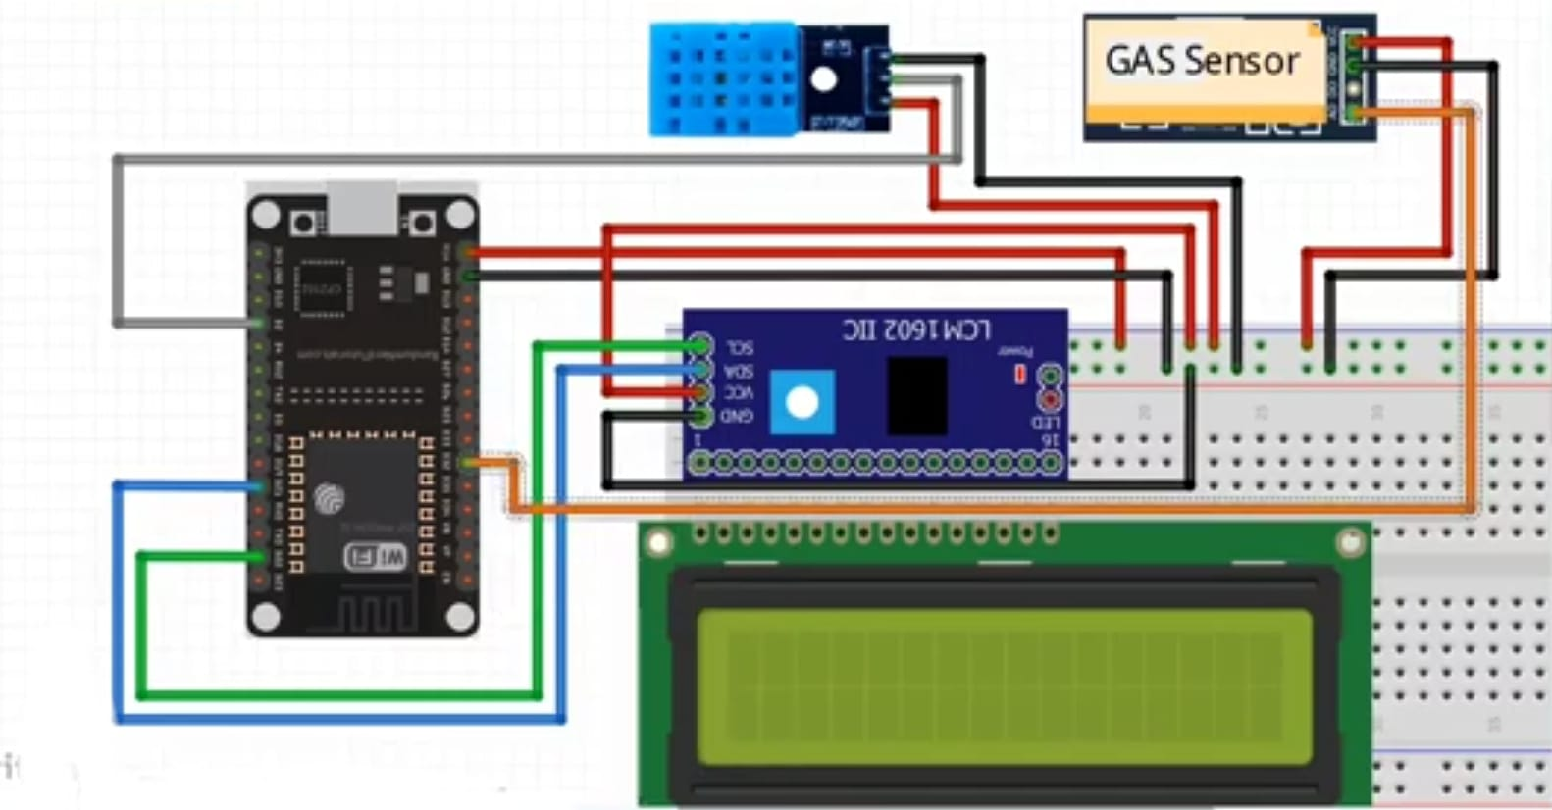

7. Methodology
The IoT-based smoke and flame detection system is designed to provide early detection and prompt alerts to prevent fire-related disasters. Its methodology integrates multiple components and processes for efficient monitoring, analysis, and response.
1.System Components
- Sensors o Smoke Detector:
Primarily sensitive to volatile organic compounds (VOCs) like alcohol, benzene, and ammonia. Also detects carbon monoxide (CO) and carbon dioxide (CO2) to some extent. A separate voltage is required for the internal heating element, usually around 5V.The MQ-135 is relatively sensitive to a range of gases, making it suitable for detecting low concentrations of pollutants.
(Refer fig.1)
o Temperature and Humidity Sensor:
Temperature and relative humidity.Temperature and humidity significantly
influence the levels of many pollutants. Operating Voltage 3.3V to 5.5V .
Relatively easy to integrate into microcontroller projects
(refer fig.2)
- Microcontroller o This system utilizes the ESP32-WROOM, a powerful and versatile microcontroller with built-in Wi-Fi and Bluetooth capabilities, to monitor air quality parameters. It integrates various sensors to measure key pollutants and environmental factors, processes the data, and transmits it to an IoT platform for remote access and analysis.
Microcontroller: Operating Voltage: 5V, Input Voltage: 7-12V, Digital I/O Pins:12, Analog Input Pins: 18 ,DC Current per I/O Pin: 12-15 mA,Flash
Memory: 4 MB, SRAM: 520 KB , Clock Speed: Up to 240 MHz (refer fig.3)
- Communication Module o A Wi-Fi module (e.g., ESP32 wroom) connects the system to the internet, enabling the transmission of sensor data to an IoT platform for real-time monitoring and alert notifications.
Wi-Fi Standard: IEEE 802.11 b/g/n, Frequency: 2.4 GHz, Data Rate: Up to 150 Mbps, Range: Up to 150 meters (refer fig.3)
- Alert Mechanisms o Remote Alerts: Notifications are sent to users via email, SMS, or app-based alerts, ensuring timely responses even when users are not on-site.

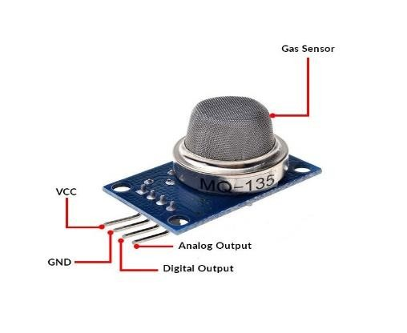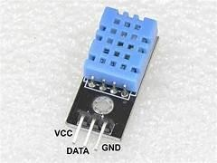
Fig.1 Fig.2
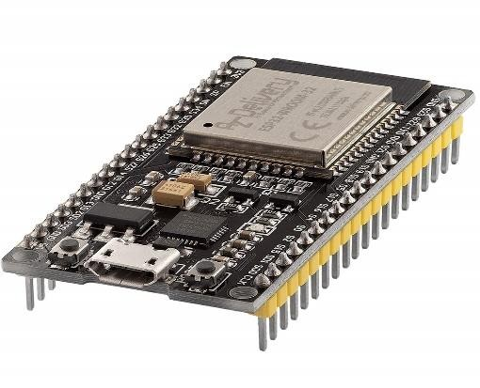
Fig.3

2. Working Process
- Sensor Data Acquisition:
Various sensors are deployed to measure different air quality parameters, Detect gases like carbon monoxide (CO), nitrogen dioxide (NO2), and benzene gas Monitor environmental conditions that can affect air quality.
- Data Processing:
The ESP32-WROOM processes the raw sensor data.Analog sensor signals are converted into digital values.Raw data may be filtered to remove noise or outliers.The microcontroller can calculate air quality indices based on the sensor readings.
- Data Transmission:
Wireless Communication: The microcontroller transmits the processed data to an IoT platform (e.g., ThingSpeak, Adafruit IO, Blynk) using Wi-Fi or other wireless protocols.
- Data Storage and Analysis:
The IoT platform stores the received data for further analysis and visualization.The platform can generate graphs, charts, and dashboards to display real-time and historical air quality data.
- Alerting and Control:
Thresholds are set for different air quality parameters.When a parameter exceeds a threshold, alerts are triggered (e.g., push notifications, emails, SMS).Control Actions: In some cases, the system can automatically trigger actions like turning on air purifiers or opening windows.

Outcome:
The IoT-based smoke and flame detector provides the following outcomes:
- Early Hazard Detection:
Quickly identifies smoke, gases, and flames, enabling prompt action to prevent fire escalation.
- Real-Time Alerts:
Sends instant notifications through alarms, LEDs, and smartphone alerts, ensuring users are informed immediately, whether nearby or remote.
- Remote Monitoring:
Allows users to monitor environmental conditions and fire risks in real-time via IoT platforms from any location.
- Data Logging for Analysis:
Stores historical data on the cloud, enabling users to analyze trends, assess risks, and improve safety protocols.
- Enhanced Safety and Efficiency:
Reduces response time to potential fire hazards, minimizing damage and safeguarding lives and property.
- Scalable and Cost-Effective:
Provides an affordable, flexible solution that can be expanded to monitor multiple locations seamlessly.

Conclusion

The development of an indoor air quality monitoring system provides an effective solution to address the growing concerns about indoor pollution and its impact on health and well-being.
By utilizing sensors to measure key air quality parameters such as CO₂, particulate matter, temperature, and humidity, the system ensures real-time data collection and monitoring. The integration of IoT technology allows for seamless data transmission and analysis, enabling users to take proactive measures to improve air quality.
This system is cost-effective, scalable, and adaptable for various environments, such as homes, offices, and public spaces. In the future, advancements like predictive analytics using machine learning and integration with HVAC systems can further enhance its functionality, ensuring healthier and safer indoor environments for all.

References
- Kumar, S. Harish, and T. C. Kanish. "A review on indoor air quality monitoring system: a mechatronics approach." Aerobiologia 40, no. 3 (2024): 373-390.
- Kumar, Vinod, et al. "Indoor Air Quality Monitoring System for Healthcare." 2024 Ninth International Conference on Science Technology Engineering and Mathematics (ICONSTEM). IEEE, 2024.
- Landage, Seema S., et al. "Solar Outdoor Air Purifier With Air Quality Monitoring System." Synergies Of Innovation: Proceedings Of Ncstem (2024): 260266.
- Mahajan, Sachit, Rosy Mondardini, and Dirk Helbing. "Democratizing air: A cocreated citizen science approach to indoor air quality monitoring." Sustainable Cities and Society 116 (2024): 105890.
- Pepe, Crescenzo, Ali Mir Farooq, and Silvia Maria Zanoli. "Control of Different Parameters for Indoor Air Quality Management Through Natural
- Ventilation." 2024 25th International Carpathian Control Conference (ICCC). IEEE, 2024.
- Al Humidi, Sara, and Tianyuan Li. "Assessing the Impact of Poor-Performing Homes on Indoor Air Quality Pre-and Post-Energy Retrofits in Low-Income Populations." ASHRAE Transactions 130 (2024): 366-376.
- Villanueva, Florentina, et al. "Indoor Environmental Quality and Effectiveness of Portable Air Cleaners in Reducing Levels of Airborne Particles during Schools’
- Youtube : Air Quality Monitoring System | ESP32 | Blynk IOT Projects https://youtu.be/mvdpAeBVIEg?si=171rfl2vDyLDbVWD

